Memo: OriGene’s response on antibody WB data
RE: Investigation of Problematic Antibody WB Verification data and Nature’s report
- Does OriGene have any comments regarding the image concerns raised in the recent report?
- Scientific data integrity is of fundamental importance to the research community. As a supplier of research reagents for more than 30 years, OriGene takes the concerns raised in the report seriously.
- We have initiated a comprehensive review of the images identified in the report, including available original data, image sources, processing history, and associated antibody validation records.
- For the four antibody images specifically highlighted in the initial report, we have completed our investigation. Our review of the available original data confirmed that the published images are consistent with the underlying experimental results. The image processing identified in these cases consisted of brightness/contrast adjustments and cosmetic removal of isolated background artifacts. Our review found no alteration of experimental bands or other changes that affected the scientific interpretation of the results. (See images below)
- A comprehensive review of the larger number of images identified in the report will require additional time. OriGene is committed to conducting this review carefully and transparently and will provide further information as the investigation progresses.
- Regrettably, OriGene could not provide a substantive response prior to publication of the Nature article. We have since initiated a formal investigation and are committed to addressing the concerns raised.

2. What actions is OriGene taking in response?
- OriGene initiated an internal investigation immediately after becoming aware of the concerns.
- We have completed our assessment of the first four Western blot images specifically highlighted in the report. Based on comparison with the available original data, we determined that the image processing in these cases was cosmetic and did not alter the scientific interpretation of the experiments.
- We are expanding this review to the additional images identified in the report. The review includes examination of available original data, image provenance, processing history, product source, and associated validation records.
- Where an image does not meet OriGene's current data-integrity standards, appropriate corrective action will be taken, including removal or replacement of the image and, where appropriate, generation of new validation data.
3. Does OriGene perform antibody validation independently, or is it performed by third parties?
- OriGene's antibody portfolio includes both OriGene-developed products and products sourced through OEM relationships.
- For OriGene-developed antibodies, validation experiments are conducted internally by OriGene. For OEM products, validation data may be generated and supplied by the respective OEM manufacturers.
- As part of the current review, we are also examining the provenance of the images identified in the report to distinguish internally generated validation data from data provided by external suppliers.

4. What is OriGene's process for validating antibodies and publishing validation images?
- OriGene has dedicated scientific teams responsible for antibody validation and review of experimental data before publication on our website.
- Historically, limited image processing, including adjustments to brightness and contrast, was permitted to improve visualization for online presentation. Cosmetic removal of isolated background artifacts was also permitted under previous practices, provided that such processing did not alter experimental bands, signals, controls, or the scientific interpretation of the experiment.
- The recent report has prompted us to reassess these historical practices against evolving expectations for scientific image integrity and transparency.
5. Is OriGene changing its processes in response to the report?
Yes.
- The report has reinforced the importance of preserving the visual authenticity of scientific images, even when cosmetic processing does not affect the underlying scientific result.
- OriGene has therefore revised its Western blot image-processing procedures. Cosmetic removal of background artifacts is no longer permitted. Image adjustments will be limited to those consistent with current scientific data-integrity standards, with the objective of preserving an accurate representation of the original experimental data.
- We are also reviewing the images identified in the report. If we determine that an image does not meet our current data-integrity standards, we will remove or replace it. Where appropriate, we will conduct a new validation experiment and publish newly generated data.
- OriGene remains committed to providing researchers with reliable products, scientifically meaningful validation data, and transparent information about our products.

4 OriGene SKUs that was listed in the June 29th report by Richardson and David

TA803489:
Lamin A (LMNA) Mouse Monoclonal Antibody [Clone ID: OTI3F6)] SKU: TA803489
Original X-ray image | Web image | Contrast-adjusted image from the report
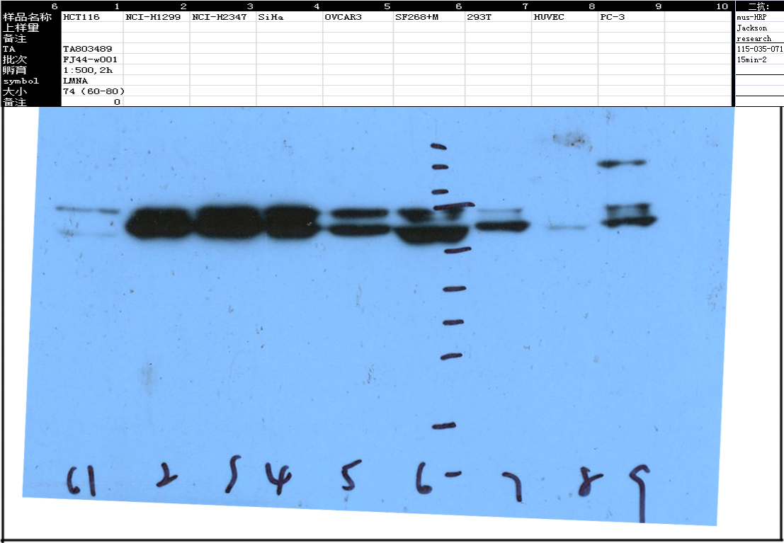 | 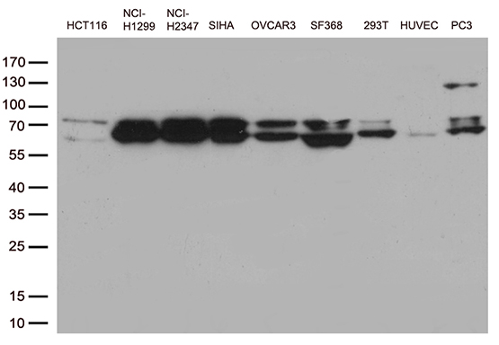 | 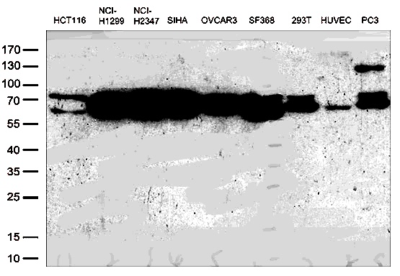

TA803494:
Lamin A (LMNA) Mouse Monoclonal Antibody [Clone ID: OTI1B7)] SKU: TA803494
Original X-ray image | Web image | Contrast raised image from the report
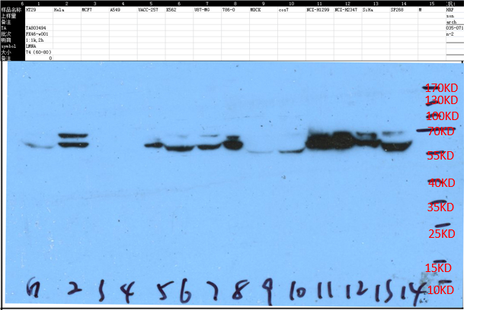 | 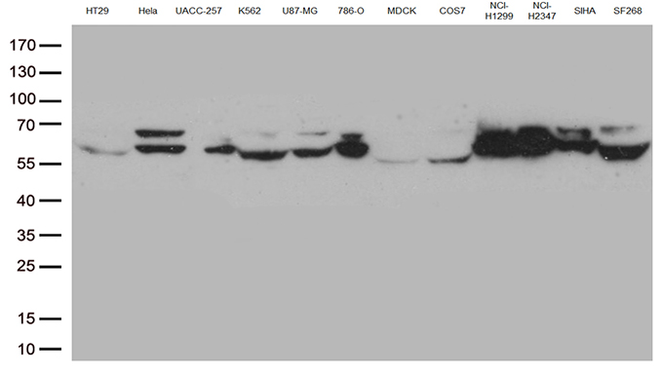 | 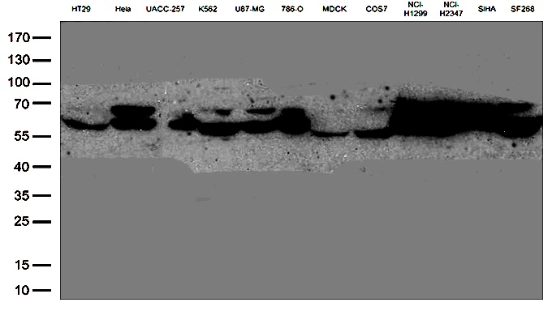

TA8034945:
Lamin A (LMNA) Mouse Monoclonal Antibody [Clone ID: OTI2G1)] SKU: TA8034945
Original X-ray image | Web image | Contrast raised image from the report
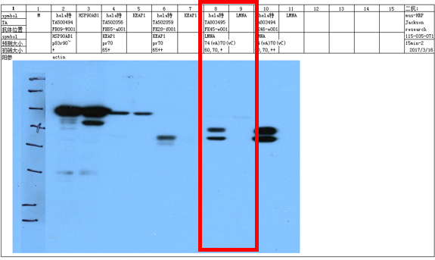 | 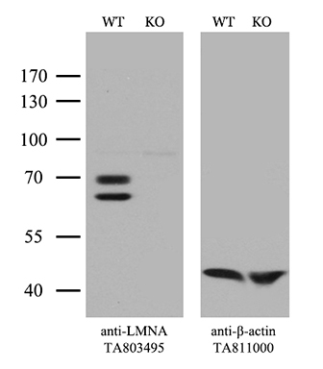 | 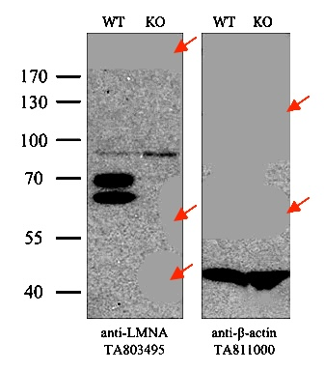
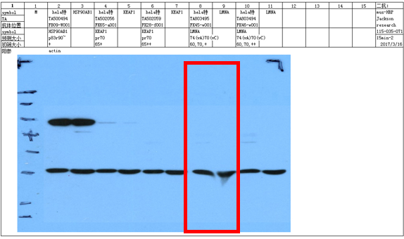

TA806591:
BCL2 Mouse Monoclonal Antibody [Clone ID: OTI9D3] SKU: TA806591
Original X-ray image | Web image | Contrast raised image from the report
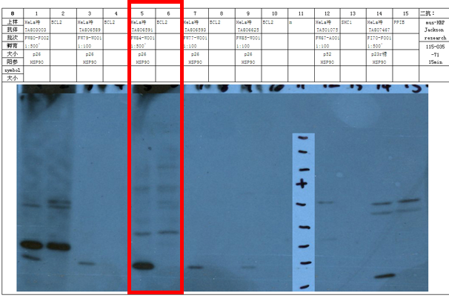 | 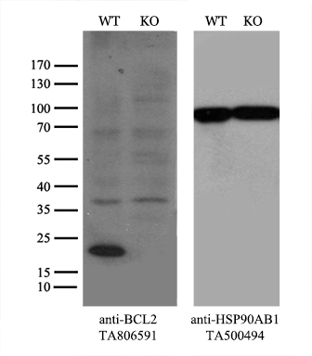 | 